
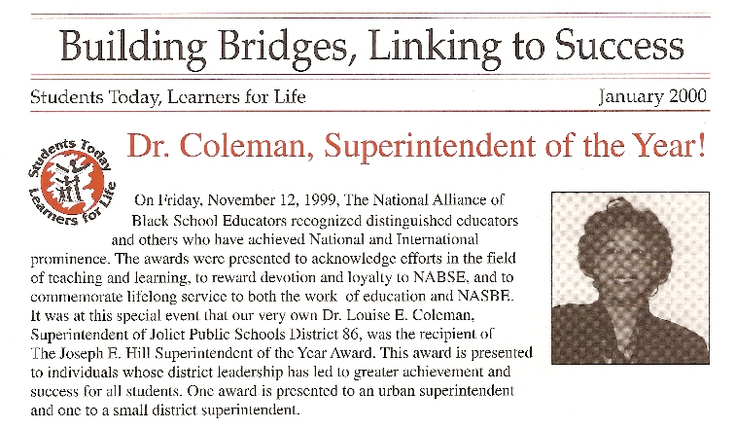
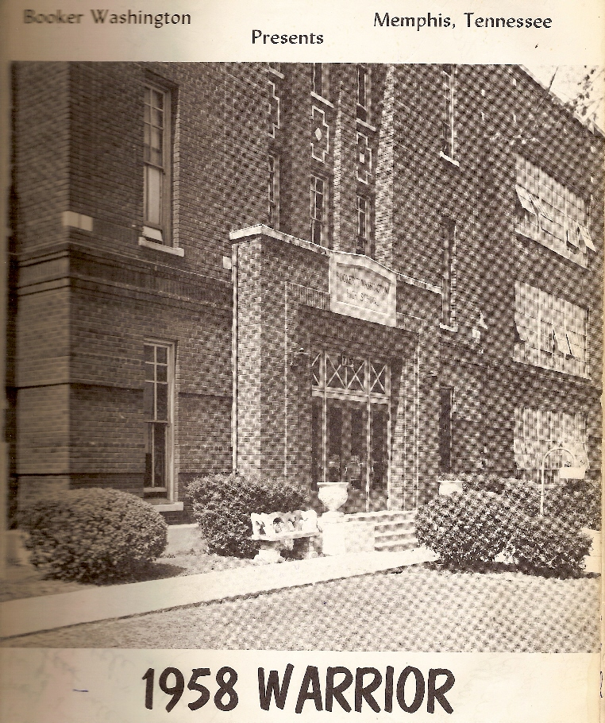
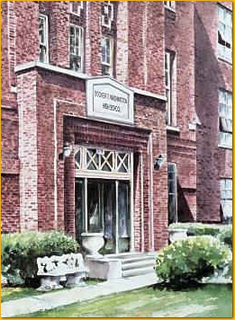
Class of 1958
“The Golden Sequel;
Remember the Past …
Imagine the Future”
50th Graduation Anniversary
June 2008
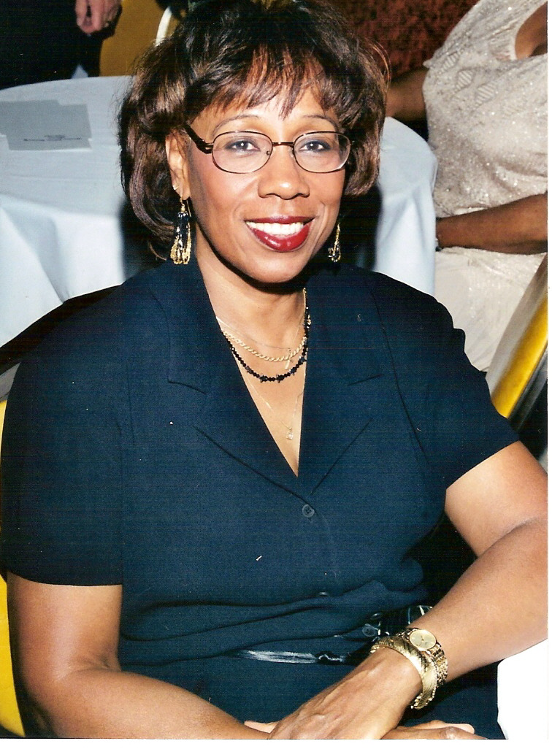

Education:
1968 | Chicago Teachers College | B.S
1980 | Loyola University | M.A.
1994 | University of Illinois | Ed.D.
Professional Experience:
2006-Present | Governor’s State University | Adjunct Professor
2000-2006 | Lewis University | Adjunct Professor
1994-Present | National Educational Consultant
1990-2000 | Joliet Public Schools | Superintendent
1986-1990 | Taft School | Principal
1968-1986 | Raymond Elementary | Teacher
1958 Graduate

Louise “Jackie” Brown

2008
Dr. Louise E. Coleman-Freeman

Awards & Honors

01/02 Lifetime Achievement Award- Lewis University; 01/01 Rainbow Push-Joliet Affiliate Award; 02/00 Roger Osman Award-Distinguished Service United Way; 11/99 Superintendent of the Year Award-National Alliance of Black School Educators; 02/98 “Women of Excellence” Award-Midwest Christian Women’s Conference; 11/92 Athena Award-Chamber of Commerce; 07/92 Gold Star Award-“National Hook-Up of Black Women”; 02/89, 02/90, 02/94 Honorary Life Membership-National Congress of Parents and Teachers; 02/90 Outstanding services as an educator-resolution by Senator Thomas Dunn and approved by the Senate; 12/89 Outstanding services to Joliet Dist. 86-resoultion by Joliet Board of School Inspectors; 10/89 Illinois Distinguished Educator Award-ISBE and Milken Family Foundation; 07/89 Certificate of Merit-Joliet Black Pride Committee; 12/88 Featured in Joliet Herald Christmas newspaper “Taft School Positive About Students’ Success”; 11/88 Appeared on Channel 7 Documentary “Schools That Work”; 10/88 Kizzy Image, Achievement and Service Award- The Black Woman Hall of Fame Foundation; 07/88 “Phenomenal Women” Award-NAACP; 04/84 Governor’s Master Teacher Award-ISBE; 05/83 Outstanding Teacher of the Year-Raymond School District 11 PTA.

Reflections of A Warrior
“The Golden Sequel:
Remembering the past, imagining the future”
Professional Memberships:
Illinois Children HealthCare Foundation; Council of Working Women; Joliet Chamber of Commerce; Suburban School Superintendents; American Administration of School Administrators; Illinois Association of School Boards; National Alliance of Black School Educators; Will County School Administrators; Joliet Regional Chamber of Commerce; United Way; Boys and Girls Club; Boy Scouts of America; Kiwanis Club; Illinois Women Administrators; BTW Alumni; Delta Kappa Gamma; Phi Delta Kappa; Professional Problems Committee.

